A Binned-Profile Approach to the Color Blending Problem

in Transparent See-Through Displays

Author 1*

Organization or School

Abstract

See-through displays allow users to view both digital content and physical objects at once. In such displays, light coming from background objects mixes with the light originated in the display, causing what is known as the color blending problem. Color blending is an important issue for the wider adoption of see-through displays and AR in general as it affect the legibility and color encodings of digital content, with a negative impact on the general usability of such displays. Color preservation aims at reducing the impact of color blending by finding an alternative color which, once blended with the background, would result in the original color. At the heart of color preservation is the capacity to predict how digital and background colors blend for a particular display.

In this paper we propose the binned-profile model for color prediction and preservation in see-through displays. The binned-profile model is based on the observations that each display renders colors differently and that background colors are changed by the display medium before blending. For a given display the model uses a colorimetric profile of how such display shows colors; with colors binned to a small set of “noticeably different” colors. We validate our model by measuring the accuracy of the predictions against other prediction models (direct model and chromatic adaptation transformations). Then, we introduce a color correction algorithm and measure the accuracy of the corrections. We investigated our approach with an extensive set of digital and background colors and different hardware configurations (projector-based and OLED displays). Finally, we elaborate on the usability and design implications of our approach for color preservation.

**Keywords**: Color Blending, Optical See-through Displays, Color Binning, Color Correction, Color Perception.

**Index Terms**: H.5 [Information Interfaces and Presentation]: H.5.1: Multimedia Information Systems — Artificial, Augmented, and Virtual Realities; H.5.2: User Interfaces — Ergonomics, Evaluation / Methodology, Screen Design, Style Guides

# Introduction

Optical see-through displays allow users to view both digital content and physical objects at once. They come in multiple form factors (e.g. head mounted displays or projection-based) and are used in augmented reality (AR) as a way to enhance the real world with digital information. Although other technologies can also be used for AR (e.g. video see-through displays), optical see-through displays have the advantage of letting users see the real world with their own eyes, without reducing its fidelity and preserving properties like lighting, texture, color, age and wear. Researchers investigate optical see-through displays for a wide range of applications including medical, maintenance, education and training (see [1][3][5] for a comprehensive list of applications); with a few consumer electronics have started to adopt them [6][Android glasses]. We can expect wider adoption of such technologies with the introduction of novel mobile AR platforms like Google Glass [], and the continuous development of transparent LCD (Samsung NL22B [[link](http://www.samsung.com/us/business/commercial-display-solutions/LH22NLBVLVC/ZA)], Eyevis [[link](http://www.eyevis.de/index.php?article_id=163&clang=1)], RichTech [[link](http://www.richtechsystem.com/html/transparent-video-showcase.html)]) and OLED displays (Futaba Corporation [[link](http://www.oled-info.com/futabas-oled-road-map-amoleds-2014-transparent-and-flexible-oleds-cars-2015)], Fujitsu [[link](http://www.fujitsu.com/be/Images/Workplace_of_the_Future.pdf)], Winstar [[link](http://www.winstar.com.tw/newspaper_ov.php?lang=en&ID=153)]).

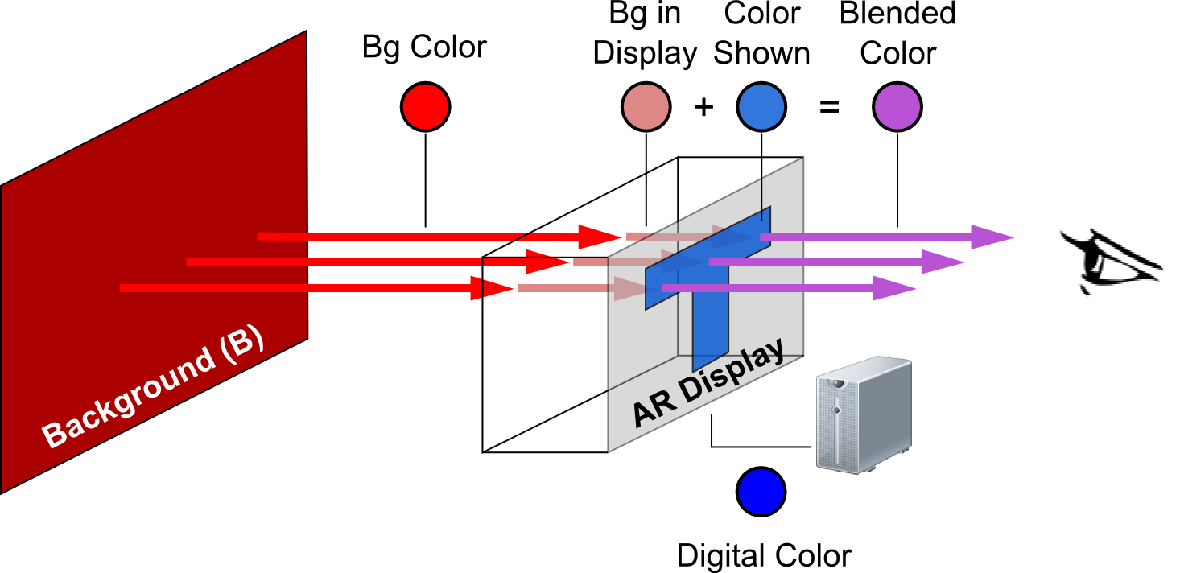

Figure 1. Color blending including the screen distortions for background and digital colors.

An important aspect of optical see-through displays is that background light coming from real-world object mixes with the light emitted by the display, something that has been described as color blending [1]. Color blending is an important issue as it can affect the legibility and color-encoding of digital information, and compromise the general usability of such devices. Despite being a widely acknowledge problem for the adoption of optical see-through displays and general AR applications, little research exists on how to preserve digital colors exposed to color blending. To preserve a digital color a system should find an alternative digital color which, upon blending with such background, comes closest to the desired digital color. Existing solutions include blocking background light, and iterative correction and measuring of the digital content. PROBLEMS WITH THIS APPROACH.

LEAVE 0.5 INCH SPACE AT BOTTOM OF LEFT COLUMN ON FIRST PAGE FOR COPYRIGHT BLOCK

* email address

An effective approach to preserve digital color in see-through displays relies on its *prediction* accuracy, i.e. the capacity to estimate the blend resulting from a given background and digital colors and for a particular display. In this paper we argue that high prediction accuracy requires taking into account two distortions introduced by the display and shown in Figure 1: (1) the way a particular display renders colors, and (2) the effect of the display media on the background color. To address the first distortion we propose the binned profile prediction model: a model that divides the continuous universe of colors into discrete and finite bins and measures how the display actually renders each bin. To address the second distortion we measure the background color only after passing through the display. We compared our model with other approaches to the *direct model*, the *chromatic adaptation transformation* (*CAT) model*. The direct model ignores the effect of the display on the digital colors; the CAT model uses known transformation matrices to determine the way a display shows particular colors.

We used a colorimeter to measure the accuracy of the different prediction models on three transparent see-through displays. Results showed that prediction with the binned-profiled model and background display distortion outperforms other combinations. We compared the accuracy of color preservation using the binned-profile model against using the direct model, with and without the background display distortion. Results showed our model outperforms the direct model correcting a wider range of colors and with higher accuracy.

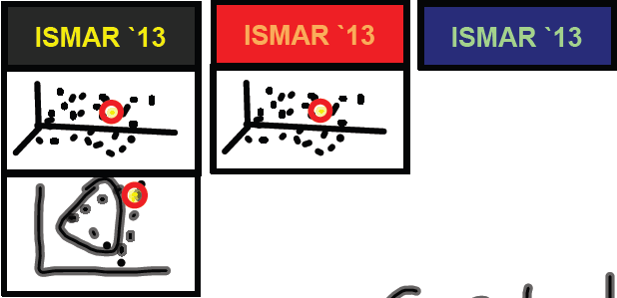

Figure 2. Examples of color blending

This paper contributes to the field of augmented reality in several ways: 1) we propose a novel approach to color prediction and preservation for optical-see through displays; 2) we validate our approach against other possible solutions; 3) we discuss the implications of color blending for situations where color preservation is not possible or contrast preservation is preferred; and finally 4) we discuss the challenges associated to incorporating our algorithm into everyday optical see-through display platforms.

# Background

Color blending is the phenomenon where background light coming from real-world object mixes with the light emitted by the display and changes it. Figure 2-top shows examples of color blending for a yellow text over three different background conditions: no background (black), red and blue. Figure 2-bottom shows the corresponding shift in color: the yellow text shifts toward orange when the background is red, while the green text shifts toward green when the background is blue. Field studies of AR applications with optical see-through displays reveal that the clarity and legibility of digital colors are affected by such changes in normal outdoors conditions; i.e. the colors in text and icons are altered (change in hue) or washed out (de-saturation) [Pingel and Clarke 2005]. Such changes affect the user interface and can render it useless: e.g. text might turn unreadable when washed out, or color encoded information such as red warning icons might lose their visual meaning.

Gabbard et al. studied such color changes in optical see-through displays [6] by building an experimental test-bed and examining foreground (27 colors on the edge of the RBG gamut) and background colors (6 common outdoor colors – foliage, brick, sidewalk, pavement, white and no background) of different lighting level and hues. His results showed how light background colors affect all other colors by pulling them towards white; while background colors of different hues pull all colors toward them. They defined the color blended and perceived by a user (CP) as a function of the light source (L1), the reflectance (RF) of background object (B), the light emitted by the display (L3), the interaction of both L1 and L3 in the display (ARD), and the human perception (HP). Equation 1 describes the interactions:

(1)

Our goal in this paper is to offer a solution to the color blending problem by means of colorimetric compensation: carefully selecting the color shown by the display so that the resulting blend comes close to the color originally intended. At the core of color compensation is the capacity to estimate how two colors blend; more specifically, how a color showed by the display blends with a particular background color. To do so we take equation 1 as our starting point and unravel the interaction of colors on the display (ARD) to account for two externally observable distortions. The first distortion is due by the fact that each display represents digital colors differently, and that it is such representation the one to consider when estimating color blending. Figure 3-left shows the color red (#FF0000) as displayed by different screens. Figure 1 illustrates this distortion as the difference in hues between the “digital color” (DC) and the “color shown” (CS): for a given digital color, different displays produce light of different hues. The second distortion is due to the display medium changing the background color before blending (BCD). Figure 3-right shows the foliage color as seen through different screens. Figure 1 illustrates this distortion as the difference in hues between the “bg color” and the “bg in display” color. In our formulation we simplify the light and reflectance of the background (the RF(L1,B) component of equation 1) into the single entity “background color” (BC). Moreover, we leave the influence of human perception of colors for our future work. Thus, we formulate color blending as follows:

(2)

Key to our understanding of color blending is the characteri-zation of the fdDC and fdBC functions. The fdDC function describes the way a particular display shows a given digital color. The fdBC function describes the way a background color is altered by the display medium.

To explore the nature of these functions we use three different optical see-through displays, a standard LCD display for background colors, and a colorimeter for color measurements (see section 4 for a detailed description of our experimental test-bed). To examine the colors in the background display, the digital colors on optical see-through displays and the resulting color blends we used the notations of the *Commision Internationale de l’Éclairage* (CIE) color model. We use the CIE 1931 XYZ color space for color measurement and addition required by equation 2. However the XYZ color space resembles the working of the human visual system which is more sensitive to colors in the blue or green hours. Therefore, we used the CIE 1976 Lab color space, a perceptually uniform color space, to calculate the perceptual difference between colors; e.g. the distance between a color and its shift when blended, or the distance between a blend prediction and the measured blend.

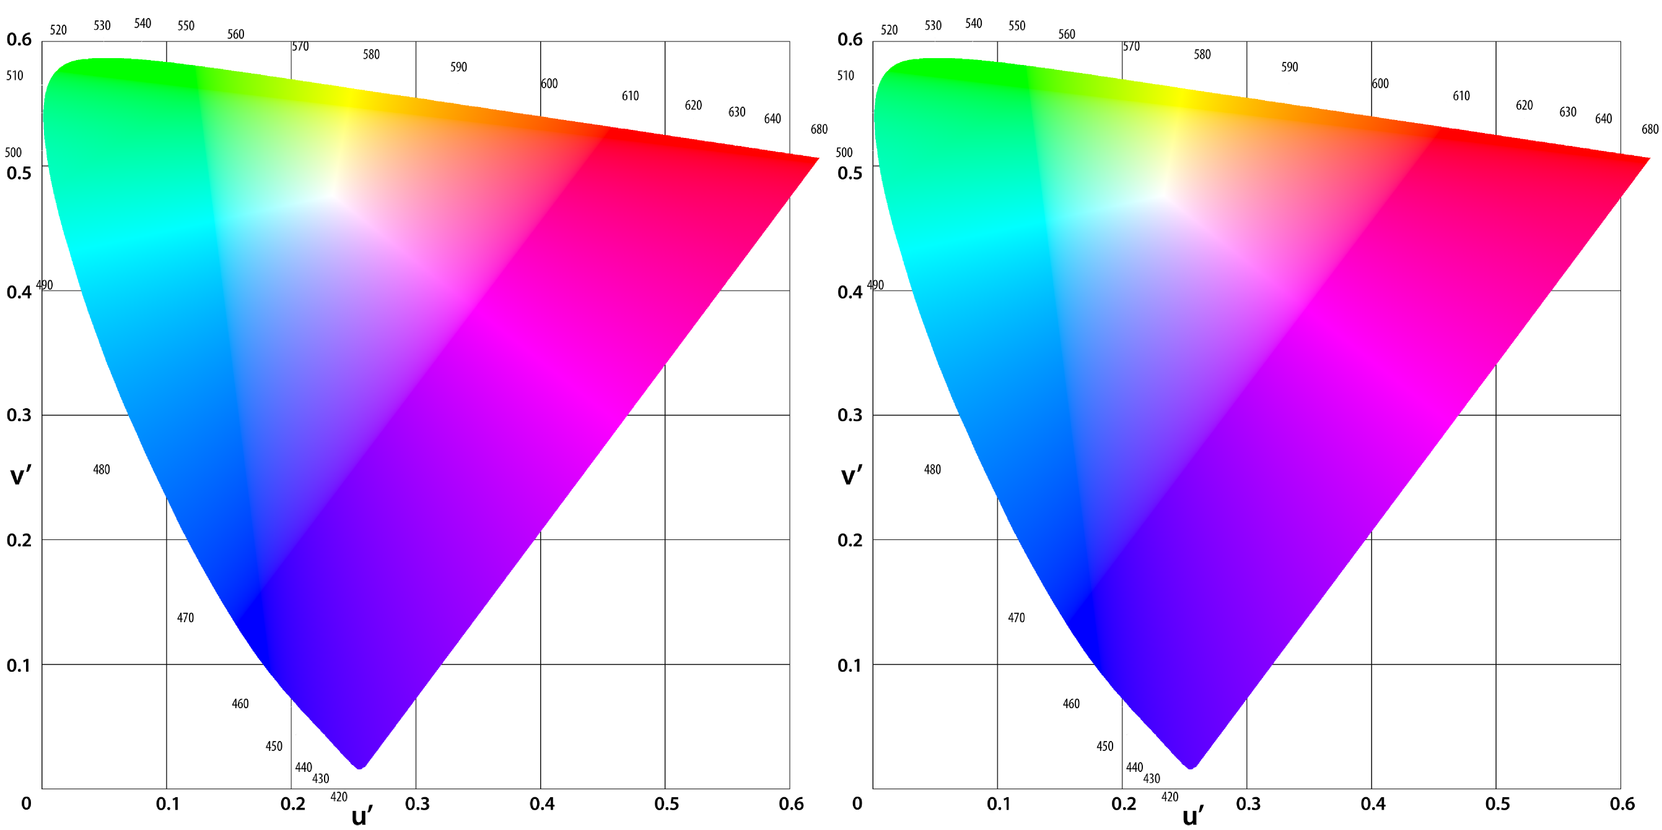

Figure 3. Left: The digital color #FF0000 and as displayed by different optical see-through displays. Right: The folieage color, and as it is seen through different optical see-through displays.

# Related Work

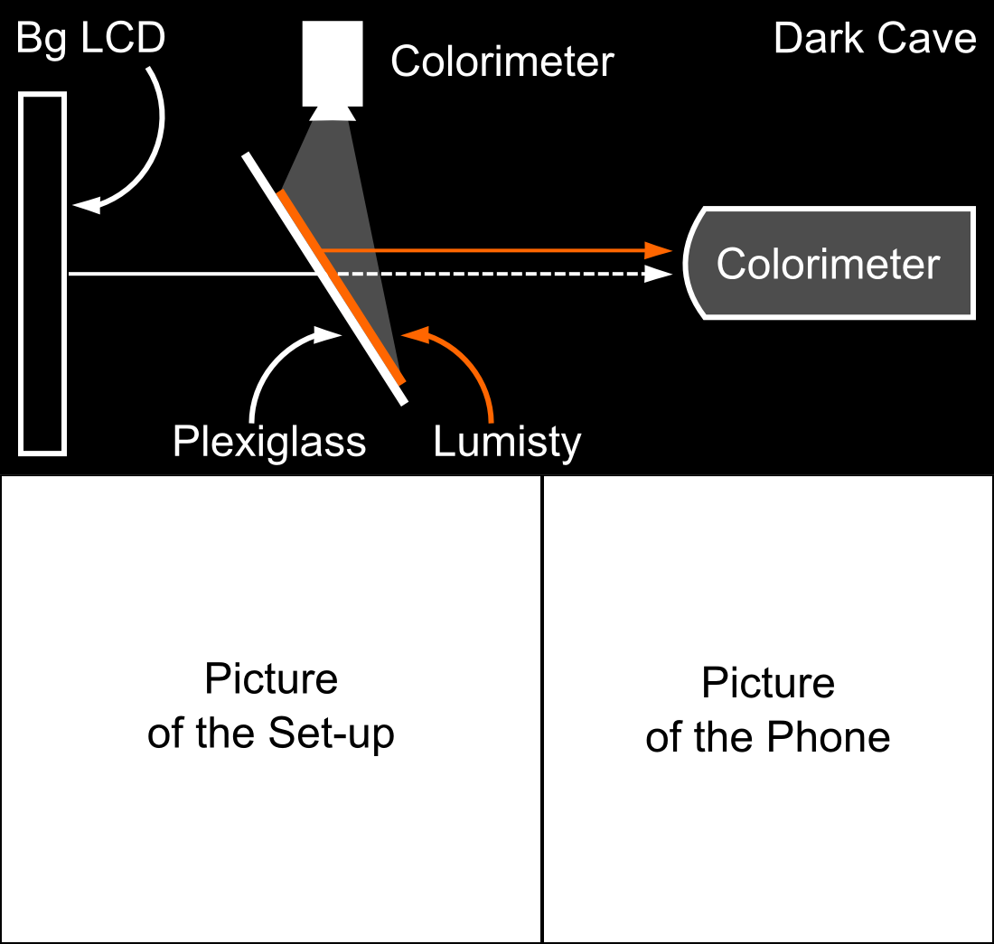

Figure 4. Experimental test-bed

Researchers have long discussed color blending as a significant perceptual challenge for the field of AR [13] especially in outdoor environments. Field studies of AR applications highlight that such inability so see the display clearly is worse with bright sunlight and with the sun lower in the sky [9]. In order to improve the display visibility users resort to strategies like looking for a dark spot (dark surface or shadow) or placing a hand in front of the display. Both strategies require users to switch context between their activity and the display and often missing important information. Strategies like these inspired researchers to investigate automatic ways to improve display clarity. A simple approach is to dynamically increase the intensity of the digital content (mentioned in [11]), however such solution is not always efficient [9]. Leykin and Tuceryan capture the field of view of the user and classify this image into zones where digital text would be readable or unreadable [14]. In a similar fashion, Tanaka et al. developed a layout system that relocates digital content to the darker areas of the display [17] taking into account restrictions like ordering of the components.

Color blending is also an important factor affecting the effective occlusion of physical objects by digital content; a feature particularly useful when the real environment is enhanced with 3D virtual objects that are intended to look real, such as in architectonical previewing. Without effective occlusion, the virtual object is perceived as translucent and unreal [4] and can confuse users [16]. Solving the occlusion problem keeps digital content from being affected by the physical objects in the background, thus solving the color blending problem. The main approach to solving occlusion has been to stop the light coming from the background by enhancing head-mounted displays with light blocking devices such as a transparent LCD [10][12][18] or spatial light modulators (SLM) [4]. In this approach a black/white depth mask of the scene is generated with the black pixels covering the area where digital content is not to mix with the background light. Therefore, digital colors projected on the black areas as seen in their original hue and lightness. Another solution is to control the illumination of the physical objects in a way that areas behind digital content remain in the dark. Noda et al. explored this approach by constraining digital objects into a dark room [15], while Bimber and Frölich implement it via occlusion shadows in a virtual showcase [2]. Finally, occlusion support has also been achieved by placing in spatial AR by placing the parts of the optical system behind the augmented object, such as Inami et al.’s usage of retro-reflective material as optical camouflage [8].

Our approach differs from the existing solutions as we aim not to change the location of user interface elements and not to add new hardware components to the see-through display; rather we seek to manipulate the color shown by the see-through display; an approach known as colorimetric compensation or color correction.

Colorimetric compensation in projector-based see-through displays. Color correction in projector-based spatial augmented reality. Our approach differs from other approaches to color correction because…

# Experimental Test-Bed

We designed and built an experimental test-bed to generate background colors at different lighting conditions, show colors on multiple see-through displays, and measure the resulting color blending (Figure 4).

To generate different backgrounds we chose an XXXX LCD display calibrated at the standard white point of D65, a white that accurately reproduces the color spectrum as it exists outdoors. This approach to generating the background color is restricted by the color gamut of the LCD. Our test-bed design takes distance from previous systems [6] which prioritize the capacity to obtain background colors as seem in everyday outdoor settings; our design prioritizes the capacity to automatically produce a wide variety of colors. For our experiments we used background colors from the Macbeth color chart, as they mimic those colors of everyday natural objects like skin color, foliage and flowers. Figure 5 shows the difference between the theoretical background colors and the ones produced and captured in our test-bed.

Our test-bed works with three see-through displays: two projector-based and one transparent OLED. The projector-based displays use XXX mm thick transparent acrylic surface covered with a Lumisty MFY 2555 film ([http://www.lumistyfilm.com](http://www.lumistyfilm.com/)) and one of two projectors at 40 degrees. The first projector is an Epson 1705 at 2200 lumens, hereafter called the p2200 display. The second projector is an Epson VS35ow at 3700 lumens, hereafter called the p3700 display. For the transparent OLED display we used a Lenovo S800 phone [7] which has a 240x320 transparent OLED display at 167 ppi. The phone display is covered in acrylic and with a total XXX mm thickness. The test-bed has a holder for the displays at YYY cms in front of the background LCD.

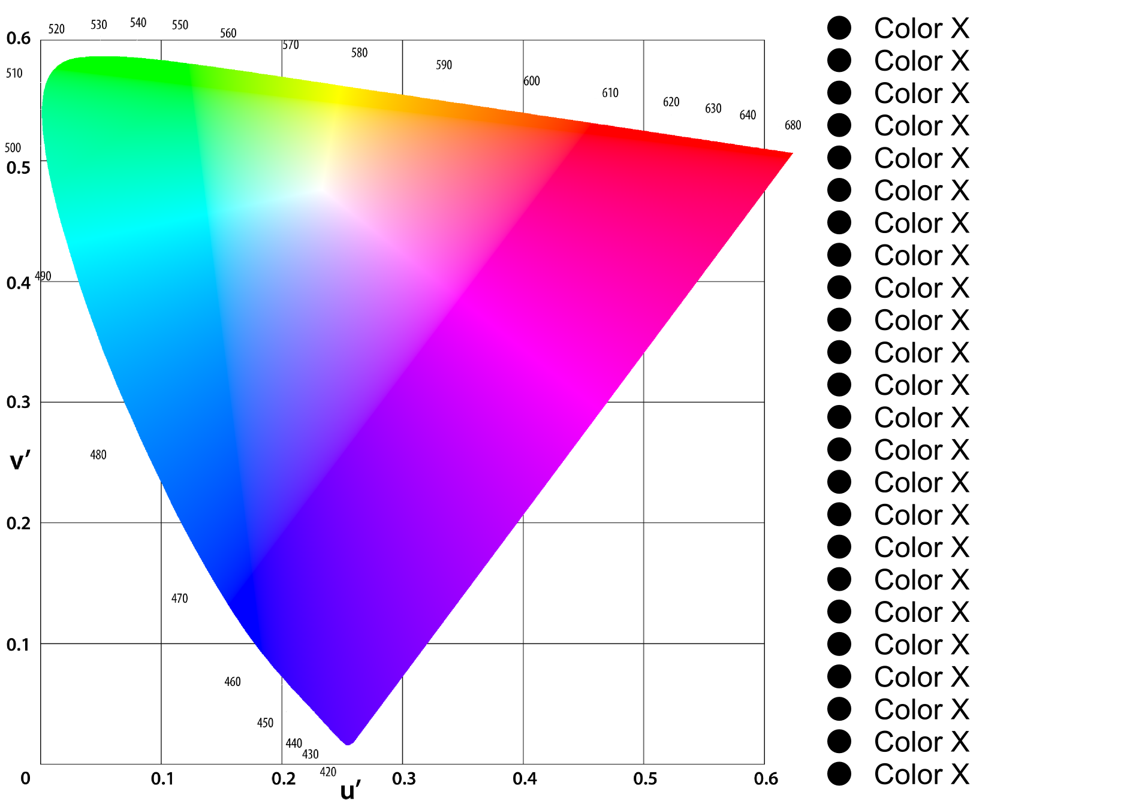

Figure 5. Background color set in the experimental set-up.

To collect data we used a Konica Minolta CS-200 luminance and color meter at a 0.2 degrees angle (standard observer angle). The colorimeter sits at XXX cms from the see-through display holder. All displays and colorimeter are connected to the same controlling computer and are kept from any outside light by an enclosure (represented in Figure 4 as the dark cave).

# Color Prediction

In order to build an accurate color preservation system, it is necessary to have accurate estimations of how the resulting blend for a give pair of background and foreground colors. Providing such estimation requires to unveil the fdDC and fdBC distortion functions of equation 2. This section investigates the first factor through five different display rendering models: direct model, three

Direct Model (show the binned-color space)

However, the colors involved in the blending differ from the “pure” ones assumed by the direct model. Figure 3-left shows

Show the new conception of color blending as presented in figure 4.

Say that to investigate this effect we took two approaches: cat and binned profile.

CAT (show image with the three cats for each display 3x3)

Binned-profile (show image with the binned-profile of each display), say that we are interested in this given the high variation of the CAT profiles. Tell hw we built each profile. Say that a limitation of this approach is the memory overhead (bytes per color pair).

## Data Collection

Describe how we collected data for each display

Describe how we computed the blending prediction for each model.

## Results

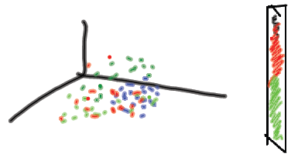

Figure 8. Single prediction result

Show one sample 3D image for a given display with the direct model and the binned profile to demonstrate the differences in the blue dots.

Show the BIG bar charts image (5 models X 3 displays X 27 backgrounds)

# Color Preservation

Correctable range (by bg color)

# Discussion

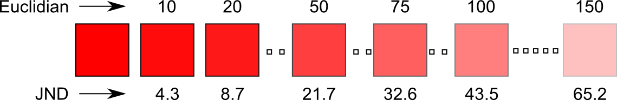

Figure 6. Examples of Euclidian distances and their corresponding just-noticeable difference.

Colors that can be corrected regardless of the background

Camera-based color correction

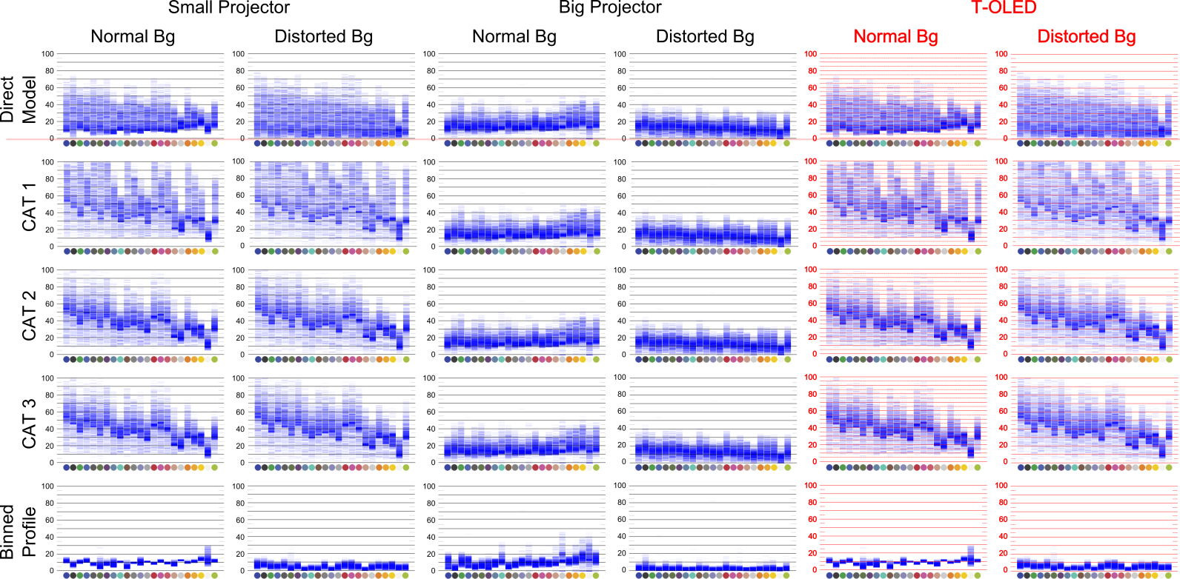

Figure 7. Prediction results

# Conclusions

References

1. Azuma, R., Baillot, Y., Behringer, R., Feiner, S., Julier, S., and MacIntyre, B. 2001. Recent Advances in Augmented Reality. IEEE Comput. Graph. Appl. 21, 6.
2. Bimber, O., and Fröhlich, B. 2002. Occlusion Shadows: Using Projected Light to Generate Realistic Occlusion Effects for View-Dependent Optical See-Through Displays. In Proc. ISMAR '02.
3. Bimber, O. and Raskar, R. 2005. Spatial Augmented Reality: Merging Real and Virtual Worlds. A. K. Peters, Ltd., Natick, USA.
4. Cakmakci, O., Ha, Y., and Rolland, J.P. 2004. A Compact Optical See-Through Head-Worn Display with Occlusion Support. In Proc. ISMAR '04. IEEE.
5. Carmigniani, J., Furht, B., Anisetti, M., Ceravolo, P., Damiani, E., and Ivkovic, M. 2011. Augmented reality technologies, systems and applications. Multimedia Tools Appl. 51, 1.
6. Gabbard, J.L., Swan, J.E., Zedlitz, J., and Winchester, W.W. 2010. More than meets the eye: An engineering study to empirically examine the blending of real and virtual color spaces. In Proc. VR '10. IEEE.
7. GSM arena. (2013, March 19). Lenovo S800 – Full phone specifications. (2011) [Website]. Retrieved from <http://www.gsmarena.com/lenovo_s800-4862.php>.
8. Inami, M., Kawakami, N., Sekiguchi, D., Yanagida, Y., Maeda, T., and Tachi, S. 2000. Visuo-Haptic Display Using Head-Mounted Projector. In Proc. VR '00. IEEE.
9. Kerr, S.J., Rice, M.D., Teo, Y., Wan, M., Cheong, Y.L., Ng, J., Ng-Thamrin, L., Thura-Myo, T., and Wren, D. 2011. Wearable mobile augmented reality: evaluating outdoor user experience. In Proc. VRCAI '11. ACM.
10. Kiyokawa, K., Billinghurst, M., Campbell, B., and Woods, E. 2003. An Occlusion-Capable Optical See-through Head Mount Display for Supporting Co-located Collaboration. In Proc. ISMAR '03.
11. Kiyokawa, K., Kurata, Y., and Ohno, H. An optical see-through display for mutual occlusion with a real-time stereovision system, Computers & Graphics, Volume 25, Issue 5, October 2001, Pages 765-779.
12. Kiyokawa, K., Ohno, H., and Kurata, Y. 2002. Occlusive optical see-through displays in a collaborative setup. In Proc. SIGGRAPH '02. ACM.
13. Kruijff, E.; Swan, J.E.; Feiner, S., 2010. Perceptual issues in augmented reality revisited. In Proc. ISMAR’10. IEEE.
14. Leykin, A. and Tuceryan, M. 2004. Automatic Determination of Text Readability over Textured Backgrounds for Augmented Reality Systems. In Proc. ISMAR '04. IEEE.
15. Noda, S., Ban, Y., Sato, K., and Chihara, K. 1999. An Optical See-Through Mixed Reality Display with Realtime Rangefinder and an Active Pattern Light Source. Transactions of the Virtual Reality Society of Japan, 4(4), 665-670.
16. Sekuler, A.B. and Palmer. S.E. "Perception of partly occluded objects: A microgenetic analysis." Journal of Experimental Psychology: General 121.1 (1992): 95.
17. Tanaka, K., Kishino, Y., Miyamae, M., Terada, T., and Nishio, S. 2008. An information layout method for an optical see-through head mounted display focusing on the viewability. In Proc. ISMAR '08. IEEE.
18. Zhou, Y., Ma, J.T., Hao, Q., Wang, H., and Liu, X.P. 2007. A novel optical see-through head-mounted display with occlusion and intensity matching support. In Proc. Edutainment'07. Springer-Verlag, Berlin, Heidelberg, 56-62.